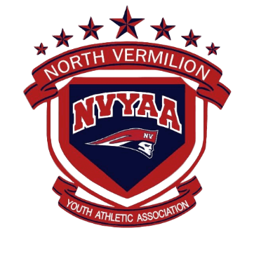

INCIDENT REPORT FORM

In the event an incident occurs before, during, or after a NVYAA activity, that a coach, parent, player, official or spectator believes is serious and warrants the attention of the North Vermilion Youth Athletic Association Board of Directors, please fill out this form and mail/email or deliver to a NVYAA Board Member immediately.

NVYAA
P.O. Box 381
Maurice, LA 70555

Date:

Complainant’s Name:

Phone: E-mail:

Sport (circle all that apply): Soccer Basketball Baseball Softball

Incident took place at a: Practice Game Other:

The incident involved a (circle all that apply): Player Coach Spectator Official

Name and/or Title and Team of person(s) involved in the incident:

Name / Title: Club:

Name / Title: Club:

Name / Title: Club:

If incident took place at a game or practice, please provide the following:

Home Coach: Visiting Coach:

Level of Play: Official(s):

In detail, describe the situation that prompted this report. Use the back of this form and any additional pages that are necessary.

claysyoung@gmail.com

